JUSTIN MORCK
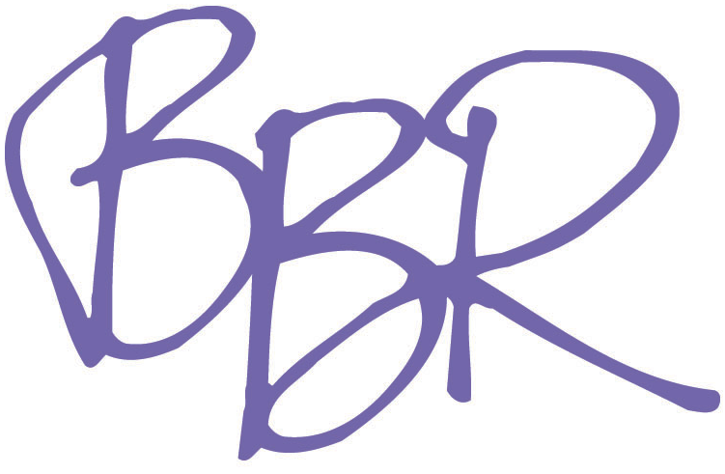
Brady, Brannon & Rich
323.852.9559
Bi-Coastal Legit
Jodie Bowman & Alisa Taylor
SAG-AFTRA
Height: 6’0”
WWW.JustinMorck.com

TELEVISION
The Young and the Restless Co-Star CBS
Agents of Shield Co-Star ABC
Bones Guest Star FOX
Mr. Robot Co-Star USA
The Blacklist Guest Star NBC
White Collar Co-Star USA
Orange is the New Black Co-Star Netflix Original Series
Elementary Co-Star CBS
Person of Interest Guest Star CBS
The Men Who Built America Lead History Channel
Momsters Lead Discovery ID
Bloody Mary’s Lead Discovery ID
Evil I Lead Discovery ID
Deadly Devotions Supporting Discovery ID
Redrum Lead Discovery ID
School Spirits Supporting Syfy Channel
Deception Cameo/Stunt Player NBC Universal
Celebrity Ghost Stories Lead/Cameo Biography Channel
Singularity Supporting Discovery Channel
Cinema Verite Cameo HBO

FILM
79’ Parts Supporting Dir. Ari Taub
Pink Lead Dir. Matt Bauer
The Last Kung Fu Monk (China) Supporting/Stunts Dir. Lipeng Zhang
Hotel Chelsea (Japan) Supporting Dir. Jorge Valdes-Iga
A Proper Violence Lead Dir. Chris Faulisi
Poolside Lead Dir. Ben Thompson
Court Jesters Supporting Dir. Eric Kepner

WEB SERIES
Mentors Supporting www.thementorsseries.com
Adultish Director/Supporting www.adultishwebseries.com
Cat Planet Lead www.thisiscatplanet.com

THEATRE
The Inert Choice Gavin The Orphans Theatre Co
Pizza Man Eddie Ripley Grier Theatre 54
Emergence Jim Producers Club
The Swan Swan Theresa Lang Theatre
RII- The Holy Terror Sir Piers Exton
The Crucible Ensemble
The Human Comedy Ensemble

B.A. in Acting & Theatre Performance, Marymount Manhattan College
Stella Adler Studio of Acting NYC: Bill Hopkins
Co-Founder/Director of The Orphans Theatre Co. NYC

SPECIAL SKILLS
US Passport, Valid Driver’s License, Stage Combat, Stunt Work

